- Title of the invention:

A System and Method for Evidence-Based Verification of Musical Instrument Recognition

- Field /Area of invention:

Artificial Intelligence, Computational Music Analysis, Digital Audio Signal Processing, Music Information Retrieval and Audio Signal verification.

- Prior Patents and Publications from literature (provide a table summarizing the prior art)

Sl. No | Prior patents and publications | Significance / Remarks relevant to the proposed invention
1. | Indian Patent, Application Number: 201921013814, System for Identification of Indian Classical Musical Instrument Sounds Using Audio Descriptors, 2019 | Proposes an audio descriptor-based framework for recognizing North Indian classical musical instruments using feature extraction and machine learning classifiers. The work focuses on feature extraction and instrument classification but does not disclose a post-recognition evidence-based verification framework employing multiple evidence criteria and evidence fusion for validating recognition results
2. | Indian Patent, Application Number: 201621012767, System and Method for Recognizing Musical Instrument Sound Using Frft Based Mfcc Features, 2016 | Proposes a Fractional Fourier Transform (FrFT)-based MFCC feature extraction approach for automatic musical instrument classification. The work enhances feature representation for classification but does not disclose a post-recognition evidence-based verification framework employing multiple evidence criteria and evidence fusion for validating recognition results.
3. | Dominika Szelega, et.al., Musical Instrument Recognition with a Convolutional Neural Network and Staged Training, Procedia Computer Science, 2022 | Presents a convolutional neural network-based approach for monophonic and predominant polyphonic musical instrument recognition. The work focuses on improving classification accuracy through staged training but does not disclose a post-recognition evidence-based verification framework employing multiple evidence criteria and evidence fusion.
4. | Sangeetha Rajesh, et.al., Musical Instrument emotion recognition using deep learning current network, Procedia Computer Science, 2020 | Presents a deep learning-based approach for music emotion recognition using musical instrument classes and audio features. The work focuses on emotion classification and does not disclose a post-recognition evidence-based verification framework for validating musical instrument recognition results.
5. | Sergio García González, et. al., Evaluating pre-trained audio embeddings for the classification of traditional Portuguese musical instruments, Machine Learning with Applications, 2026 | Evaluates pretrained audio feature extraction models for traditional musical instrument recognition within Music Information Retrieval applications. The work compares feature representations and classification performance but does not disclose a post-recognition evidence-based verification framework or evidence fusion mechanism for validating detected musical instruments.
6. | Marcela Morvidone et. al., Incorporating scale information with cepstral features: Experiments on musical instrument recognition, Pattern Recognition Letters, 2010 | Proposes novel multi-scale audio features for musical instrument discrimination and classification using enhanced timbral representations. The work improves feature representation for recognition but does not disclose a post-recognition evidence-based verification framework employing multiple evidence criteria and evidence fusion.
7. | Raghavendra Sharma, Musical Instrument Sound Signal Separation from Mixture using DWT and Fast ICA Based Algorithm in Noisy Environment, Materials Today: Proccedings, 2020 | Presents a wavelet and independent component analysis-based approach for separating musical instrument sound signals from noisy mixtures. The work addresses source separation but does not disclose an evidence-based verification framework for validating recognized musical instruments or computing verification scores.

- Summary and background of the invention (Address the gap / Novelty)

Automatic musical instrument recognition has become an important research area in music information retrieval, digital audio signal processing, and artificial intelligence. Existing advanced deep learning and transformer-based foundation models, such as CLAP (Contrastive Language Audio Pretraining) can recognize multiple musical instruments from polyphonic audio recordings by assigning confidence scores to candidate instruments. However, these confidence scores alone do not provide sufficient evidence regarding the reliability or persistence of the detected instruments throughout the audio signal. Most existing systems rely primarily on instantaneous prediction confidence for identifying musical instruments. Such approaches may produce inconsistent or unreliable detections due to variations in musical structure, overlapping instruments, transient sounds, and temporal fluctuations in confidence values. Consequently, there is no dedicated verification mechanism that systematically evaluates the reliability of detected instruments using multiple complementary evidence criteria before producing the final recognition outcome.

The present invention addresses this limitation by introducing an Evidence-Based Verification Engine (EBVE) that operates as a post-recognition verification framework. The proposed engine evaluates each candidate instrument using five complementary evidence criteria, namely ‘Confidence’, ‘Persistence’, ‘Stability’, ‘Dominance’, and ‘Continuity’, and integrates these criteria through an evidence fusion mechanism to compute a final verification score. This verification layer provides a structured and explainable mechanism for validating detected musical instruments and ranking them according to accumulated evidence, thereby improving the reliability and interpretability of the final recognition results.

- Objective(s) of Invention

- To develop an evidence-based verification framework for validating automatically recognized musical instruments from polyphonic audio recordings.
- To evaluate each detected musical instrument using multiple complementary evidence criteria, namely Confidence, Persistence, Stability, Dominance, and Continuity, rather than relying solely on raw recognition scores predicted by the existing models.
- To integrate the computed evidence through an evidence fusion mechanism for generating a unified verification score that reflects the reliability of each detected musical instrument.
- To develop a modular verification engine that can operate as a post-recognition layer with existing artificial intelligence-based musical instrument recognition systems without modifying the underlying recognition model.

- Working principle of the invent (in brief)

The proposed invention operates as an Evidence-Based Verification Engine (EBVE) that can be integrated with an artificial intelligence-based musical instrument recognition framework. Initially, an input audio signal is segmented into fixed-duration analysis windows and processed by a pretrained recognition engine to obtain confidence scores for multiple candidate musical instruments in each window. The generated recognition results are then supplied to our proposed verification engine.

The verification engine evaluates each detected musical instrument using five complementary evidence criteria, namely Confidence, Persistence, Stability, Dominance, and Continuity. These criteria collectively assess the reliability, temporal consistency, and prominence of each detected instrument throughout the audio signal. The individual evidence values are subsequently combined using an evidence fusion mechanism to compute a unified verification score for every candidate instrument.

Finally, the candidate instruments are ranked according to their verification scores, and the resulting ranked list represents the verified recognition outcome. This approach provides a structured and explainable post-recognition verification process for validating automatically detected musical instruments.

- Description of the invention in detail (Include drawing and or photograph as needed)

The overall architecture of the proposed invention is illustrated in Figure 1. The invention operates through three major stages, namely Audio Processing, Instrument Recognition, and Evidence-Based Verification, followed by the generation of the final verified musical instrument list.

Stage 1: Audio Processing
Block 1: Audio Input (.wav) - The system receives an input audio recording in the WAV format containing one or more musical instruments.
Block 2: Audio Window Generator - The input audio recording is segmented into fixed-duration windows of one second each to facilitate window-wise analysis.
Block 3: Windowed Audio Segments - The generated audio windows form the input for the subsequent musical instrument recognition stage.

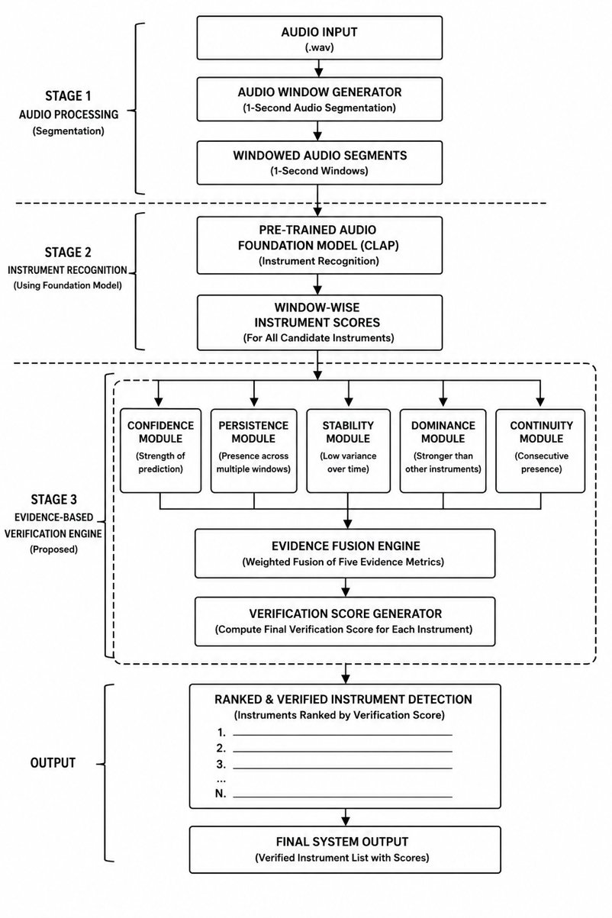

Figure 1: Overall System Architecture

Stage 2: Instrument Recognition
Block 4: Pre-trained Audio Foundation Model (CLAP) - Each audio window is processed by a pretrained CLAP foundation model that predicts the presence of multiple candidate musical instruments.
Block 5: Window-wise Instrument Scores - For every analysis window, the recognition engine generates confidence scores corresponding to all candidate musical instruments.
Stage 3: Evidence-Based Verification Engine (Proposed)
The window-wise recognition scores are supplied to the proposed Evidence-Based Verification Engine (EBVE), which evaluates the reliability of each detected musical instrument using five complementary evidence modules.
Block 6: Confidence Module - Computes the overall confidence associated with each detected musical instrument.
Block 7: Persistence Module - Determines how consistently an instrument is detected across multiple analysis windows.
Block 8: Stability Module - Measures the consistency of the confidence values throughout the complete audio recording.
Block 9: Dominance Module - Determines the proportion of analysis windows in which an instrument exhibits the highest confidence score relative to other detected instruments.
Block 10: Continuity Module - Determines the longest uninterrupted sequence of consecutive windows in which an instrument remains continuously detected.
Block 11: Evidence Fusion Engine - The evidence values generated by the five evidence modules are combined using a weighted evidence fusion mechanism.
Block 12: Verification Score Computation - A unified verification score is computed for every candidate musical instrument based on the fused evidence.
Output Stage
Block 13: Ranked and Verified Instrument Detection - The candidate instruments are arranged in descending order according to their verification scores.
Block 14: Final Verified Instrument List - The system produces the final verified list of detected musical instruments together with their corresponding verification scores.
- Experimental validation results:
A prototype implementation of the proposed Evidence-Based Verification Engine (EBVE) was developed and integrated with a pretrained CLAP-based musical instrument recognition framework. Experimental validation was carried out using polyphonic audio recordings to verify the functionality of the proposed verification framework.
The experimental results confirmed that the proposed system successfully generated window-wise musical instrument recognition scores, evaluated each detected instrument using the five evidence modules, namely Confidence, Persistence, Stability, Dominance, and Continuity, and computed a unified verification score through the proposed Evidence Fusion Engine. Based on the computed verification scores, the system produced a ranked and verified list of detected musical instruments.
Figure 2 presents a comparison between the raw recognition confidence scores obtained from the pretrained recognition model and the corresponding evidence-based verification scores generated by the proposed verification engine. Here, a sample input is raw audio file in .wav format. A song is deliberately given as input. The comparison demonstrates the operation of the verification framework in producing a consolidated verification score for each detected musical instrument.
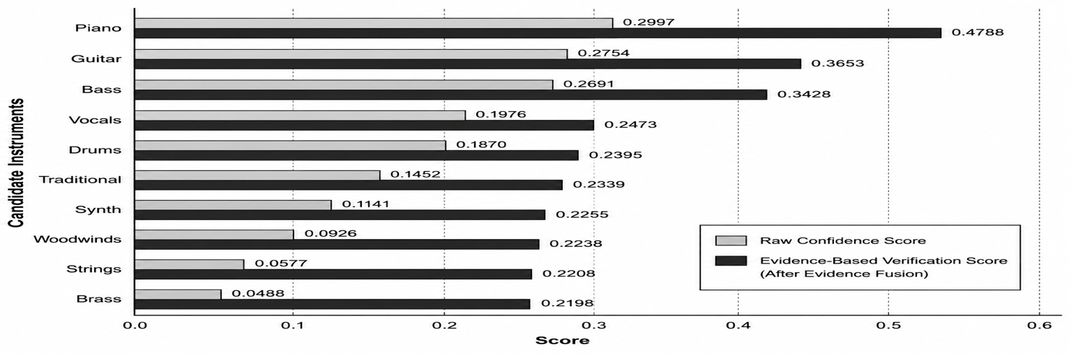
Figure 2: Score Comparison Graph
Figure 3 illustrates the evidence profiles of the top-ranked verified musical instruments using the five proposed evidence metrics. The radar chart demonstrates how multiple complementary evidence criteria collectively contribute to the final verification process, thereby providing an interpretable and structured validation mechanism.
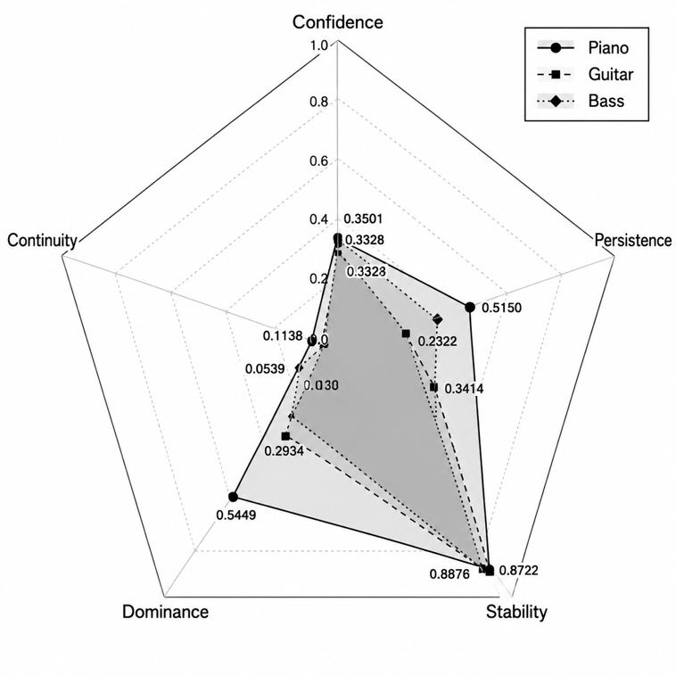
Figure 3: Verification Engine parameters Score in Radar Chart
The experimental validation demonstrates the successful implementation and functional operation of the proposed evidence-based verification framework for musical instrument verification and ranking.
Note: The above result is obtained for a sample raw musical audio file in (.wav) format. In general, the results can vary depending on the presence of musical instruments involved in that musical input audio file.

- What aspect(s) of the invention need(s) protection?

- The Evidence-Based Verification Engine (EBVE) for post-recognition verification of automatically detected musical instruments.
- The modular post-recognition verification architecture, which operates independently of the underlying musical instrument recognition model and can be integrated with existing or future artificial intelligence-based recognition systems.
- The multi-criteria evidence evaluation framework employing five complementary evidence metrics, namely Confidence, Persistence, Stability, Dominance, and Continuity, for assessing the reliability of detected musical instruments.
- The verification score-based ranking mechanism for producing a ranked and verified list of detected musical instruments.

- What is Technology readiness level of your invention? (Tick the appropriate TRL)

Research |  |  | Development |  |  | Deployment
TRL 1 | TRL 2 | TRL 3 | TRL 4 | TRL 5 | TRL 6 | TRL 7 | TRL 8 | TRL 9
Basic | Technology | Experimental | Technology | Technology | Technology | System | System | Actual system
Principles | concept | proof of | validated in | validated in a | demonstrated | prototype | complete | proven in an
observed | formulated | concept | a lab | relevant | in a relevant | demonstration | and | operational
 |  |  |  | environment | environment | in an | qualified | environment
 |  |  |  | (industrially | (industrially | operational |  | (competitive
 |  |  |  | relevant in | relevant in | environment |  | manufacturing
 |  |  |  | case of key | case of key |  |  | in case of key
 |  |  |  | enabling | enabling |  |  | enabling
 |  |  |  | technologies) | technologies) |  |  | technologies,
 |  |  |  |  |  |  |  | or in space )
Yes | Yes | Yes | Yes

----------------------END OF THE DOCUMENT-----------------------------

